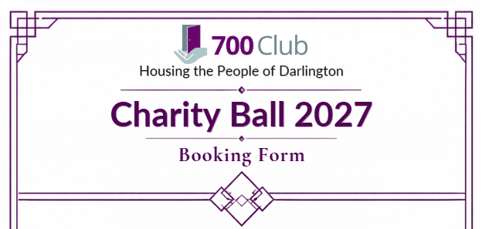

Event: | 700 Club Fundraising Charity Ball
Event date: | 2nd July 2027
Venue: | Central Hall, The Dolphin Centre, Darlington, DL1 5RP
Time: | Doors open at 6pm / 7pm start / Carriages midnight
Dress Code: | Black tie
Lead Ticket Holder Details

Full name:

Organisation (if applicable):

Email:

Phone:

Address:

Guest Details
Please list guest names (or write "TBC"). Individual tickets or tables of 8

Guests Full Name | Contact Details
1.
2.
3.
4.
5.
6.
7.
8.
Please let us know if you have any accessibility requirements we can assist with.

Number of Individual tickets required

Number of full tables
(8 guests)

Total Amount Payable: | £
Payment Method | Cash / Bank Transfer / Invoice
Bank Details: Lloyds: 700 Club / Account no: 88101260 / Sort Code: 30-92-79
Reference: (Your Name) Ball 2027

Terms & Conditions

By purchasing your Ball Ticket, you confirm that you understand and accept these Terms and Conditions.

- Tickets are non-refundable unless the event is cancelled. You may transfer to another named guest by notifying the organiser.
- Seating requests will be considered but cannot be guaranteed.
- Photographs and video footage will be taken during the event and used by the 700 Club for promotional and reporting purposes (including social media and fundraising materials). If you do not wish to appear in media content, please let us know or inform an event official on the day.
- The 700 Club accepts no liability for injury, loss, or damage suffered by participants, unless caused by our negligence.
- Participants are responsible for any property or personal belongings brought to the event.

We will use your data solely to manage this booking and, if you opt in, to send charity updates, future events and ways to support the charity:

☐ I consent to being contacted about future events.

Signature of Lead Ticket Holder:
Date:

Please return this form to: emma.mclaughlin@700club.org.uk
Roadway House, Beaumont Street West, Darlington, DL1 5SX / 01325 366397.

Thank you for supporting the 700 Club to
help the people of Darlington.

